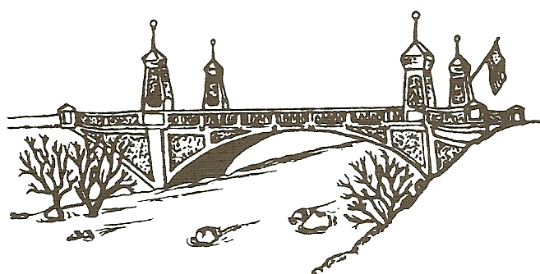

City of Asotin Council
Meeting Agenda

Meeting: Regular Council Meeting
Date: January 13th, 2025
Start Time: 5:30 PM – Regular Meeting
End Time: 6:00PM (approx.)
Location: 121 Cleveland, Asotin WA
Mayor: Dwayne Paris
Mayor Pro-Tem: Lori Loseth
Council Members: Weakland, Stein, Cowdrey, Loseth, Ottmar
TOPIC Responsible Official Category
***All agenda items are for discussion and action unless indicated otherwise***
Call to Order
- Stand for the Pledge of Allegiance
- Public Hearings
- Oral Communications – Public Comment: In consideration of others wishing to speak, your Informational
remarks will be limited to three minutes for items not listed on the agenda. Please stand, state your name
address for the records.
- Consent Calendar all matters listed under the consent calendar are considered to be routine Council Action
by the members of the City Council and will be enacted by one motion. There will be no separate discussion of
the items. If discussion is desired, the item will be removed from the consent calendar and considered separately.
- Minutes of December 23rd, 2024 Regular Meeting
- Payroll 12/31/2024 Ck# 46900 - 46904 Including EFT’s; $24,725.99
- Payroll 4th Qtr. 12/31/2024 Ck# 46905 – 46906 & 46912 - 46913 Including EFT’s; $3,639.29
- 4th Qtr. Claims 12/31/2024 Ck# 46907 – 46911 Including EFT’s; $26,054.79
- Expense Claims 0/0/2025 CK# Including EFT’s; $
- Voids: Ck#

Approval of Unexcused and/or Excused Council member’s absence: Council Action

- Unfinished Business Council Discussion

- New Business

IX. Consultant/Contractor Reports Stillman Norton Informational

X. Clerk Tina Davidson Informational

XI. Departments
- Police Monte Renzelman Informational
- City Attorney Informational
- Fire Department Shawn Balzer Informational
- Planning Commission Mercia Neace Informational

XII. Council Communications
Committee/Liaison Reports Informational
  - Steve Cowdrey-
  - Lori Loseth-
  - Tim Ottmar-
  - Craig Stein-
  - David Weakland-

XIII. Mayor’s Report Dwayne Paris Informational

XIV. Ordinances, Resolutions Etc.

      - Resolution 2025-745 – A Resolution of the City Council of the City of Asotin Washington, Notifying the Public of the 2025 City Council and Planning and Zoning Commission Meeting Dates along with the 2025 Asotin City Hall, Holiday Closure Dates.

XV. Executive Session:

XVI. Adjournment
The Council may add and/or delete and take action on any item not included in the above agenda. Any subject placed on the agenda, regardless of how the matter is stated on the agenda, may be acted upon by the Council.

AGENDA POSTED 1/8/2025

